**Employee.java**

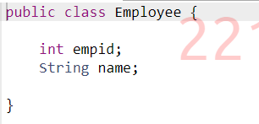

**Command1.txt**

**Command2.txt**

